Here we can see that we can tab and auto-complete a command such as ls Downlods

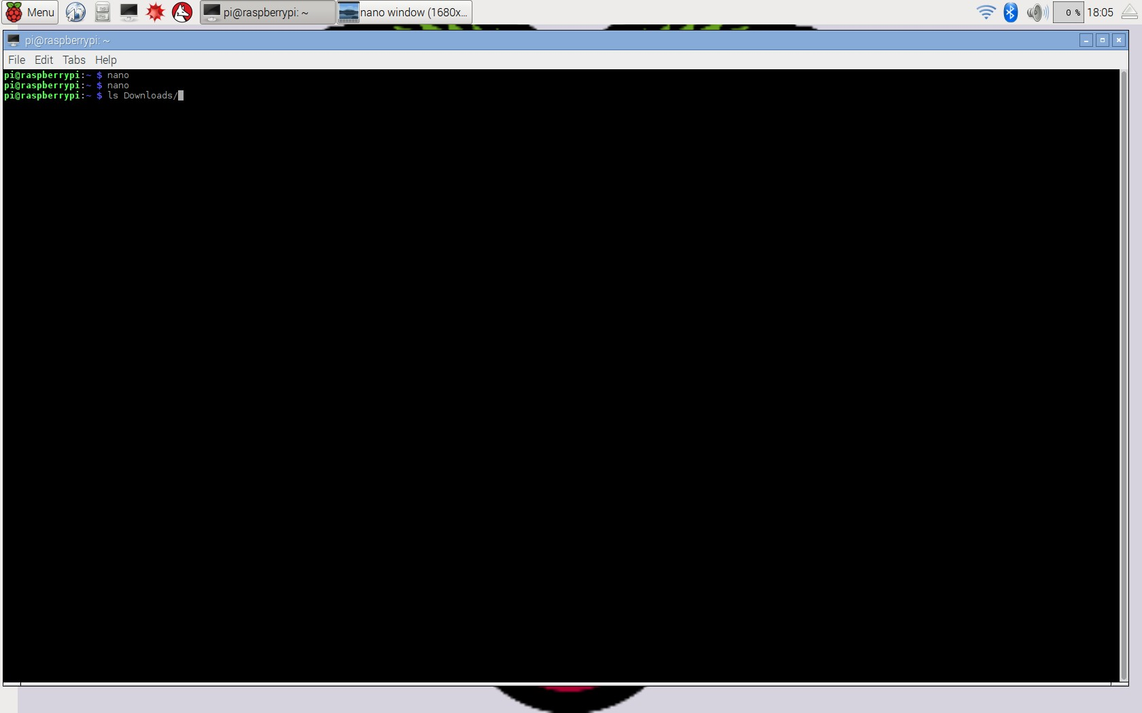

Here we can see that we can try a command and then hit the up arrow key in order to re-list the last command. 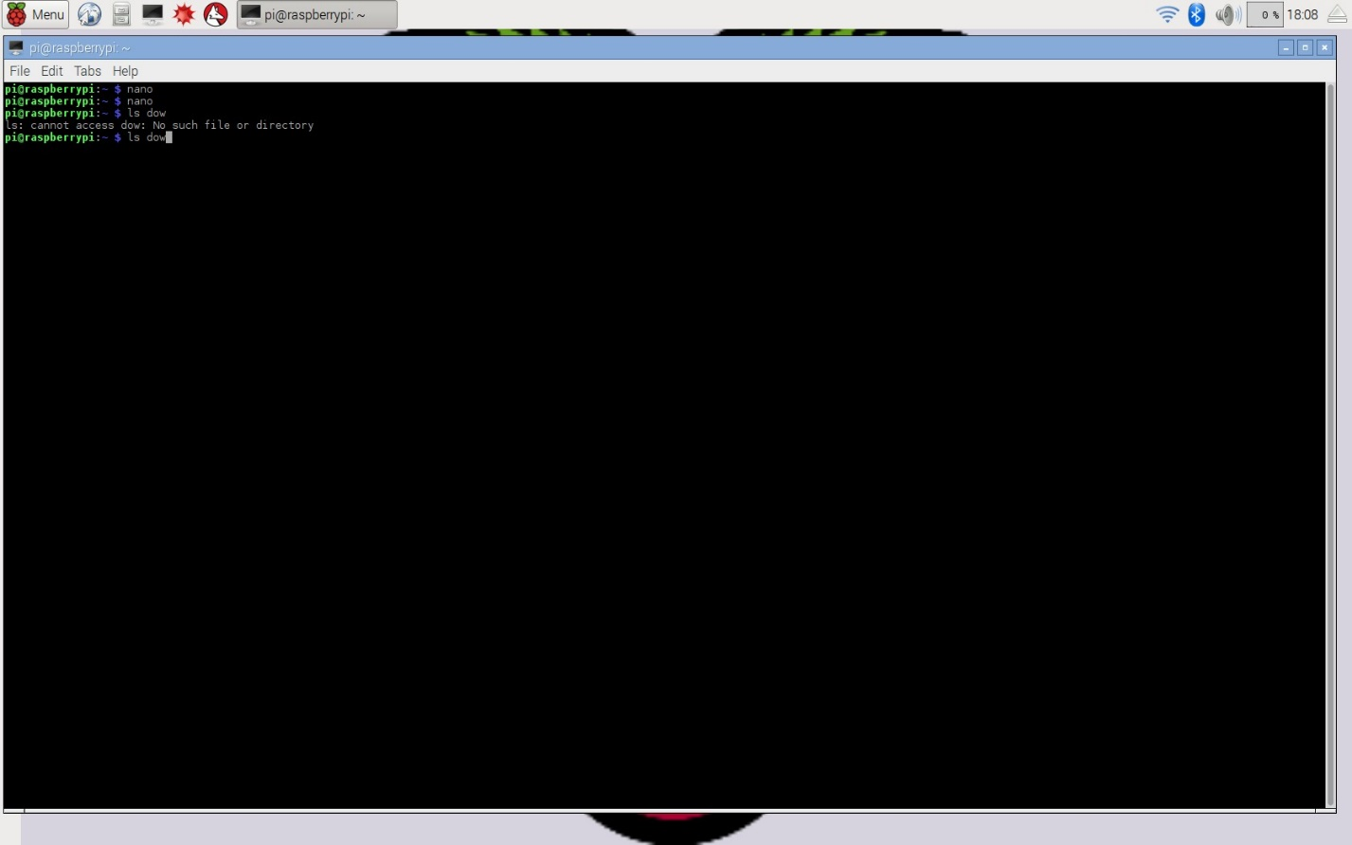

Here we can see the nano command brings up the nano editor

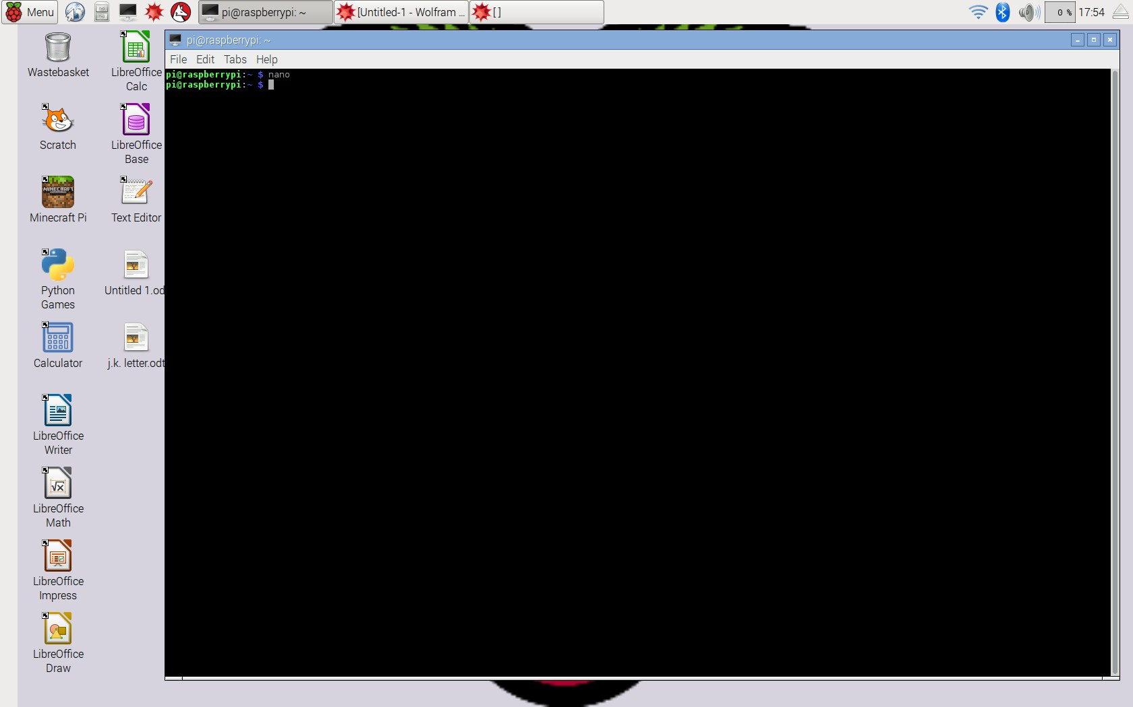

Here we can see the nano window

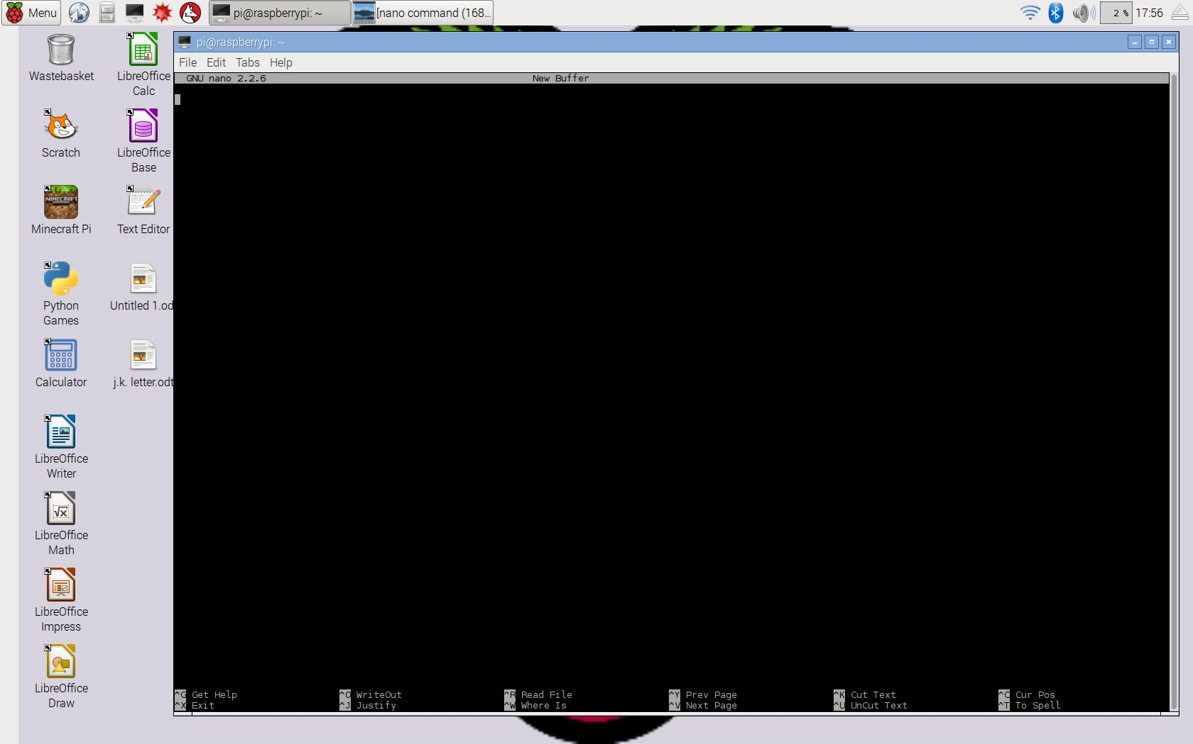

Here I input the command nano spmd2.c to create the file and then write this code.

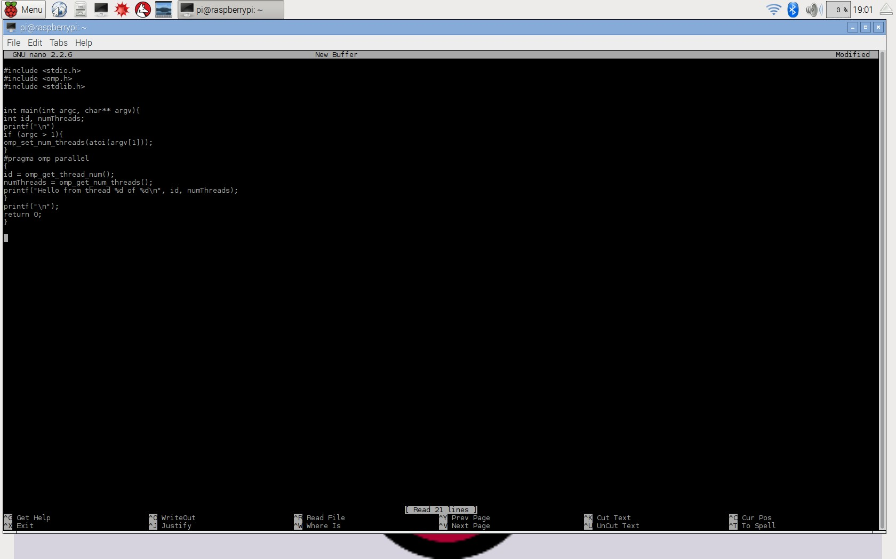

Next the code was compiled using this command: gcc spmd2.c -o spmd2 –fopenmp

A compile error was encountered and then fixed.

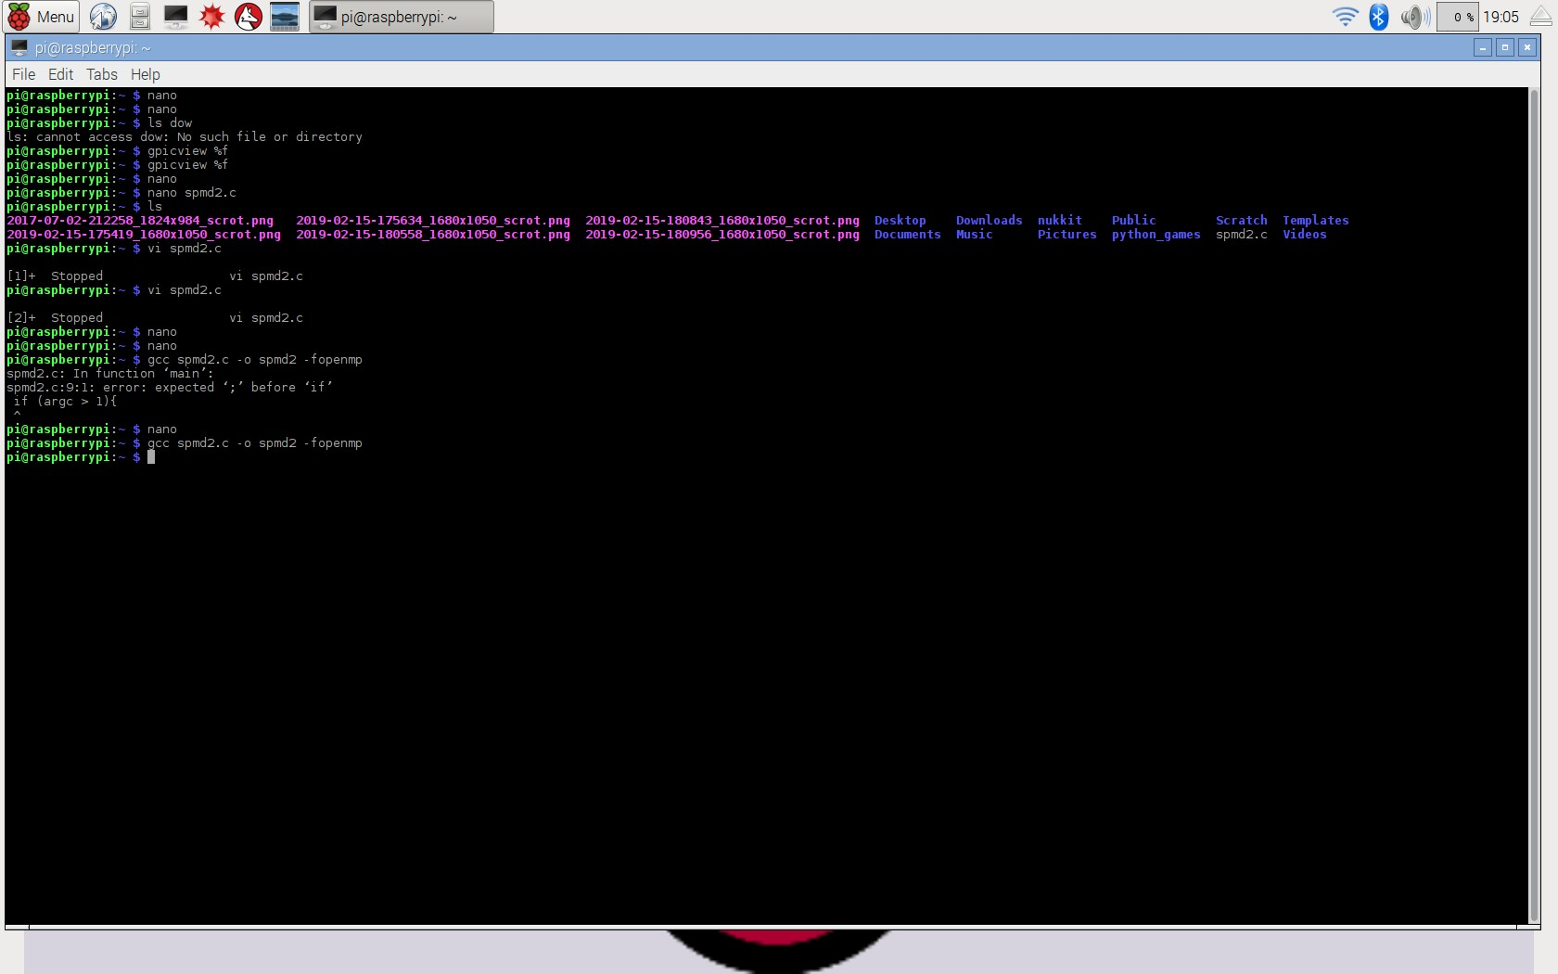

The program was run with an input of 4, 3, 2, 1. A critical section error occurred and the memory locations for each thread are shared and not mutually exclusive. Thus, the cores reported multiple duplicates of the same thread id.

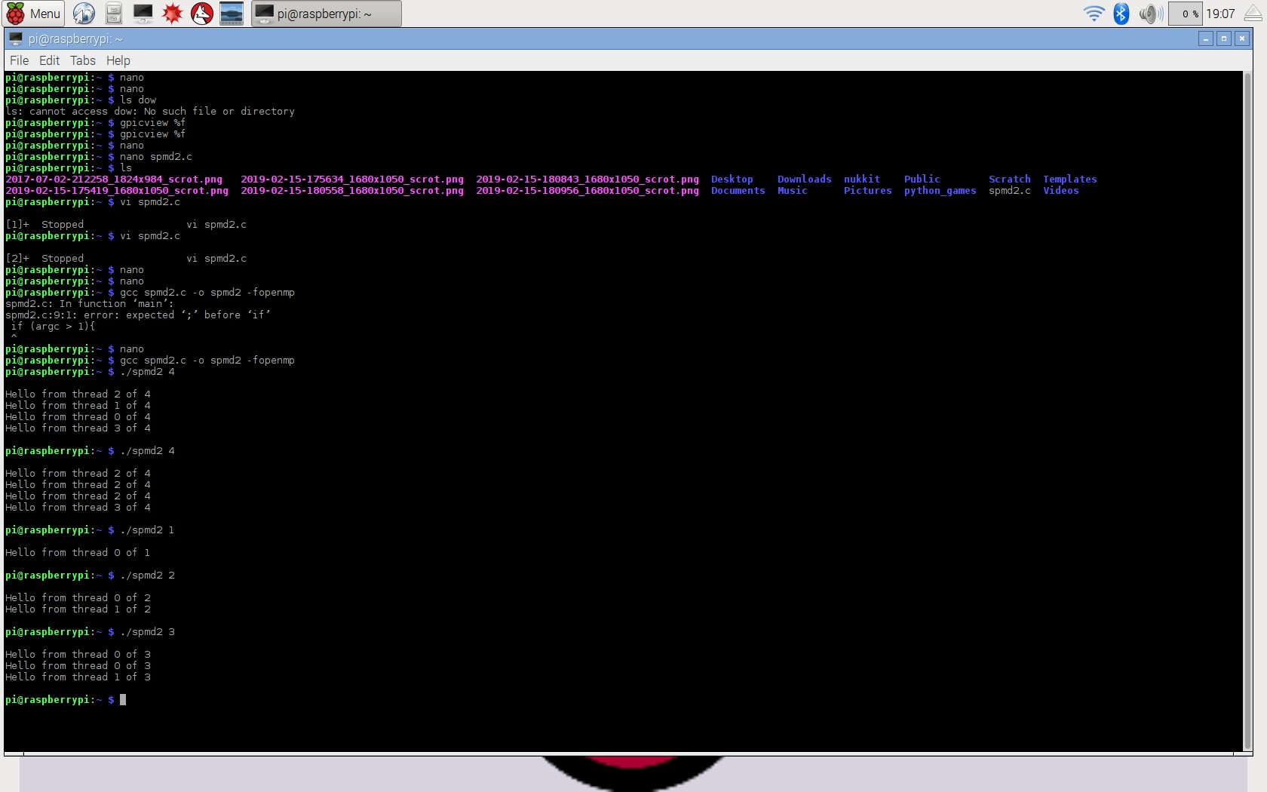

Here, two lines of code were added to allow for separate memory location for each core. Two lines were fully declared with int. And the original int variable declaration of id and numThreads were commented out.

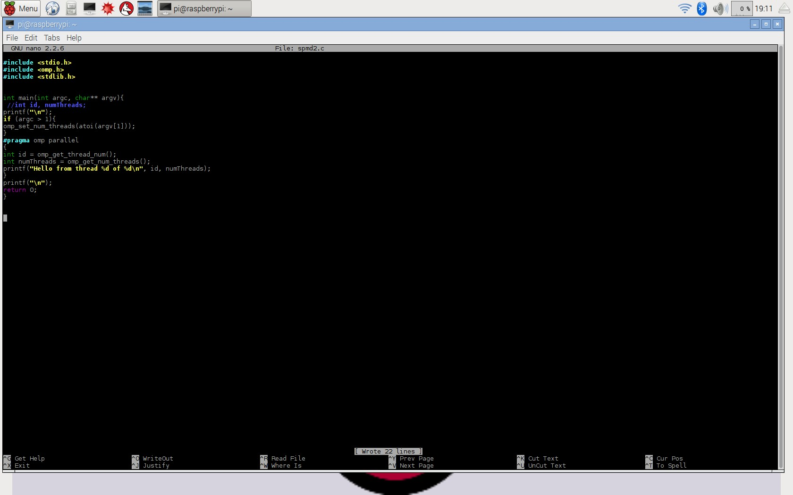

Here, below. The program has been recompiled and we have re-input 1-4 and each core is reporting in with its own unique thread id out of four.

